Skill set code | HLTSS00059
Skill set title | Venous Blood Collection Skill Set
Modification History | Release | Comments
 | Release 4 | Release 4. Supersedes and is equivalent to HLTSS00059 Venous blood collection skill set release 3. Minor change to update superseded and equivalent units of competency.
 | Release 3 | Release 3. Supersedes and is equivalent to HLTSS00059 Venous blood collection skill set release 2. Minor change to update Infection Control unit of competency.
 | Release 2 | Release 2. Supersedes and is equivalent to HLTSS00059 Venous blood collection skill set release 1. Minor change to update Infection Control unit of competency.
 | Release 1 | New skill set. This version was released in HLT Health Training Package release 3.0 and meets the requirements of the 2012 Standards for Training Packages
Description | This skill set reflects the minimum requirements for health care workers required to perform venepuncture in a clinical environment.  To achieve the HLTSS00059 Venous blood collection skill set the candidate must have completed at least 35 hours of work as detailed in the Assessment Requirements of the unit of competency.  The skills in this skill set must be applied in accordance with current Commonwealth and State/Territory legislation, Australian/New Zealand standards and industry codes of practice.  No occupational licensing or certification requirements apply to this skill set at the time of publication.
Pathways Information | These units provide credit towards the HLT37525 Certificate III in Pathology and other qualifications within the HLT Health Training Package.
Entry Requirements | N/A
Foundation Skills | The foundation skills outcomes implicit in this skill set are outlined in the below bar chart.  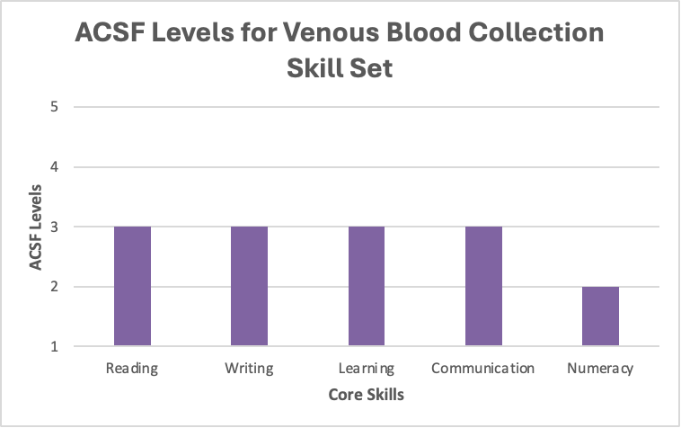  Digital literacy outcomes may be included in the Companion Volume Implementation Guide as appropriate.
Skill Set Requirements | HLTPAT008 Identify and respond to clinical risks in pathology collection  HLTPAT014 Perform venous blood collection*  HLTINF006 Apply basic principles and practices of infection control  *A mandatory workplace requirement is specified in this unit.
Skill set mapping information | No equivalent skill set.

